**Simple Calculator**

**Instruction for running code:**

1. In cmd prompt, go to project location.
2. Type: npm install
3. Type: node calculatorServer.js
4. Go to folder named ‘Public’ and open index.html

**Output:**

1. **Addition and its output**

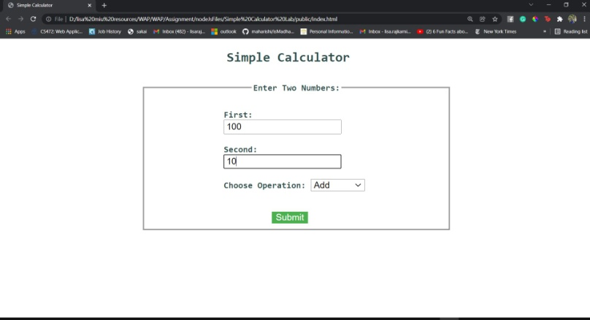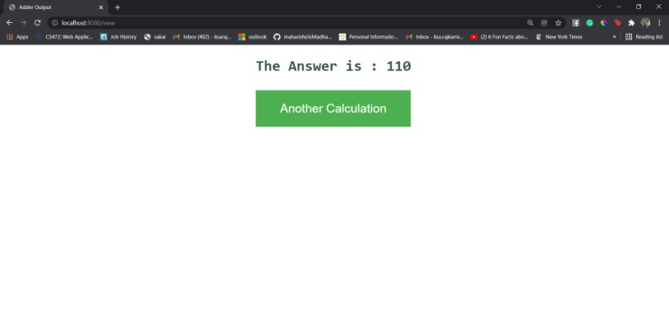

1. **2.Division and its output**

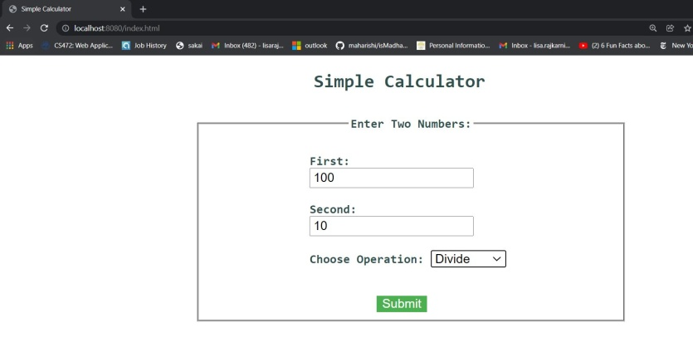

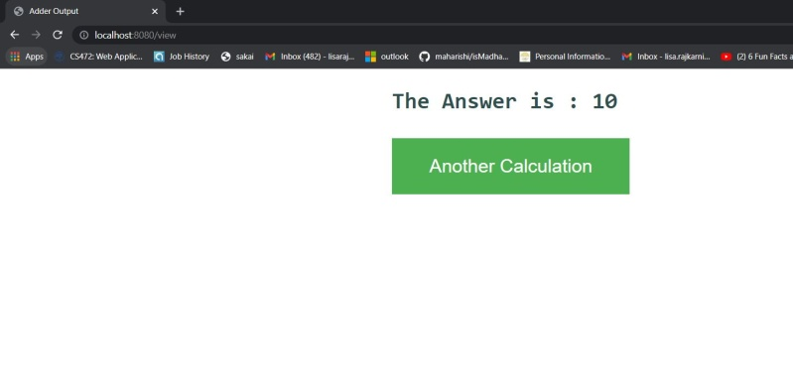

**3.Substraction and its output**

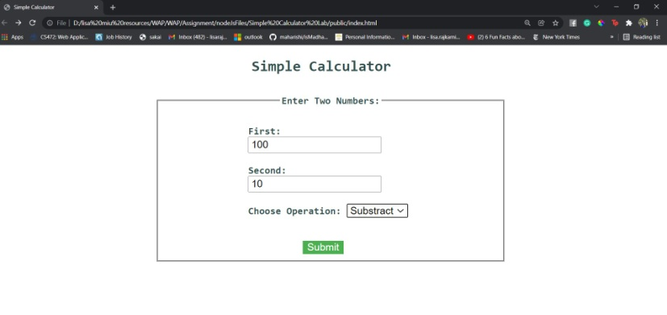 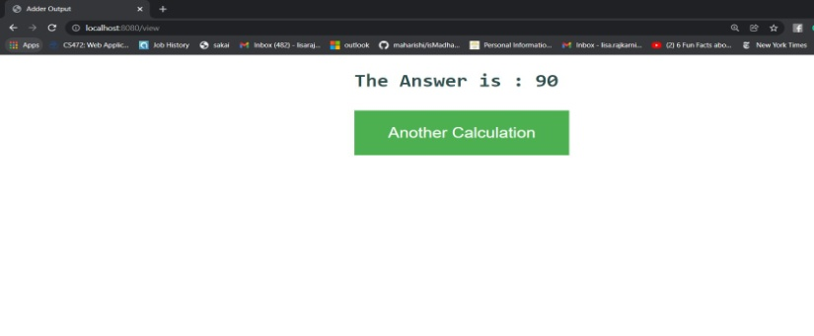

1. **Multiplication and its output**

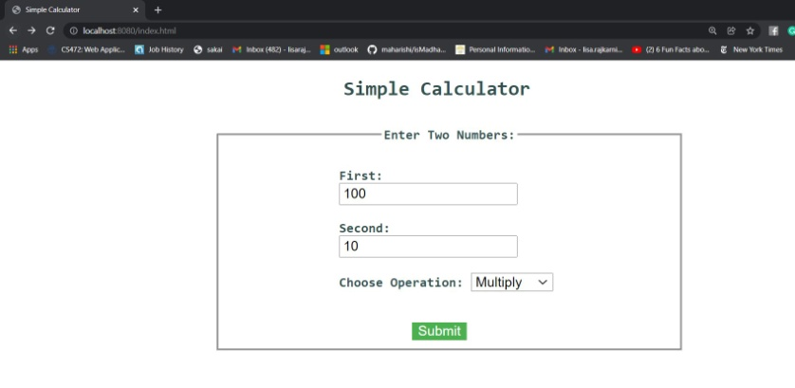

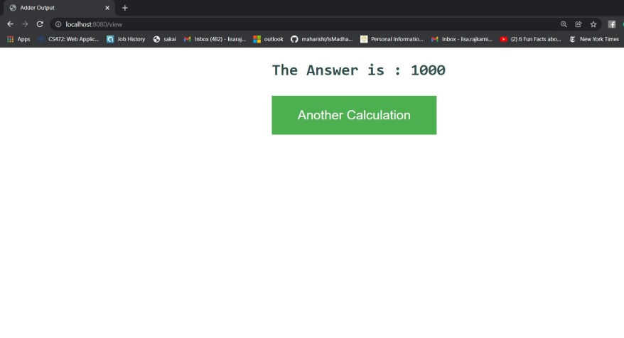

1. **When clicked on Another calculation, it shows previous window**

